
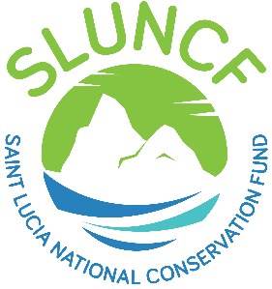

CONSULTANCY OPPORTUNITY
Consultant: Communication and Stakeholder Engagement Services -SMMA Pilot
Project: Caribbean Blue Economy Financing (BluEFin) Project
Duration: 16 Months
Location: Saint Lucia
Remuneration: Negotiable, based on qualifications and experience
The Soufrière Marine Management Association (SMMA), in collaboration with the Saint Lucia National Conservation Fund (SLUNCF), invites applications from qualified individuals or firms to provide Communication and Stakeholder Engagement Services for the implementation of a Digital Payment System (DPS) pilot within the Soufrière Marine Management Area. The consultant will support stakeholder engagement, awareness raising, user adoption, and compliance with the DPS, while promoting understanding of the relationship between user fees and marine conservation outcomes.

Application Process
Interested applicants must submit:
- A cover letter outlining relevant experience and suitability for the assignment;
- A current Curriculum Vitae (CV) or company profile.

Applications should be emailed to ceo@sluncf.org with the subject line:
"Consultant - Communication and Stakeholder Engagement Services - SMMA Pilot"
Deadline for submission: 18 July 2026
The full Terms of Reference can be accessed via the SLUNCF website at www.sluncf.org.
Only shortlisted candidates will be contacted. Late or incomplete applications will not be considered.

