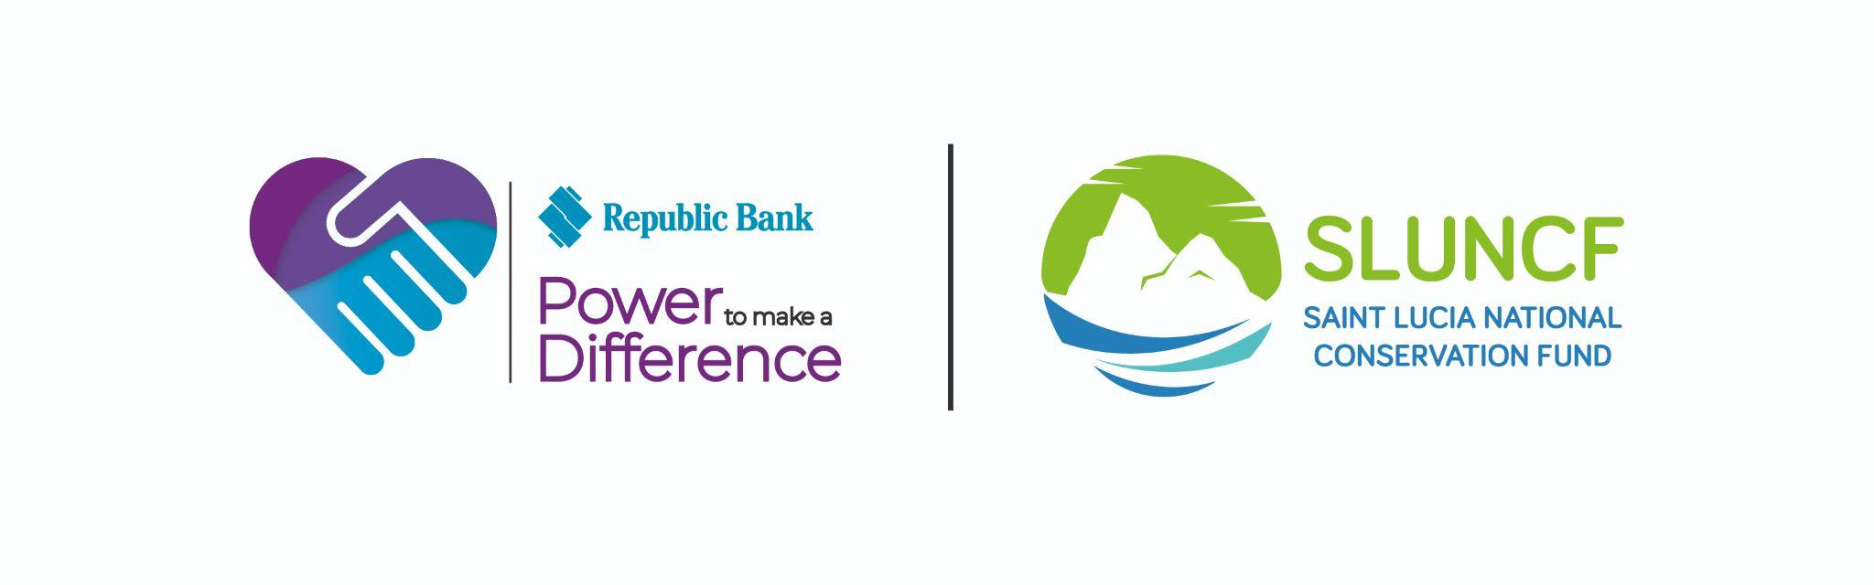

CALL FOR CONCEPT NOTES

Republic Bank Sustainability Fund – Saint Lucia
In Partnership with the Saint Lucia National Conservation Fund (SLUNCF)
The Saint Lucia National Conservation Fund (SLUNCF), in collaboration with Republic Bank, is pleased to announce a new Call for Concept Notes under the Republic Bank Sustainability Fund – Saint Lucia.
This initiative is part of Republic Bank’s “Power to Make a Difference” programme, supporting innovative, community-driven solutions that enhance environmental sustainability and resilience across Saint Lucia.

🌎 What We are Looking For
We invite forward-thinking, impact-driven initiatives that promote:
- 🌱 Environmental Awareness & Stewardship
- 📚 Knowledge Sharing, Learning & Behaviour Change
- 🌿 Nature-Based & Ecosystem-Based Solutions
- 🌊 Sustainable Management of Natural Resources
(Terrestrial, Marine, and Atmospheric systems)
Projects should demonstrate practical, inclusive approaches that inspire action, strengthen understanding of environmental issues, and contribute to long-term sustainability.

🌾 Priority Areas of Focus
Concept Notes should align with one or more of the following:
- Climate-smart agriculture, agroecology, and food systems innovation
- Biodiversity conservation and ecosystem restoration
- Sustainable coastal and marine resource management
- Circular economy approaches (waste reduction, reuse, recycling)
- Urban and community-based green initiatives
- Environmental education, awareness campaigns, and demonstration projects
- Youth-led or community-led environmental solutions
- Innovative approaches to sustainable livelihoods linked to nature

💡 What Makes a Strong Proposal
We are particularly interested in initiatives that:
- Encourage hands-on learning and practical engagement
- Promote knowledge transfer and community awareness
- Demonstrate replicability and scalability
- Integrate innovation with traditional knowledge
- Provide opportunities for participation across age groups and communities
- Include clear monitoring, evaluation, and impact pathways
Projects may:
- Introduce new ideas
- Strengthen or expand existing initiatives
- Scale up successful models

👥 Who Can Apply
Eligible applicants include:
- Government agencies
- NGOs and Community-Based Organizations (CBOs)
- Private sector entities
- Community groups and associations
- Faith-based and civic organizations
- Local institutions and organized groups committed to sustainability
(Collaborative partnerships are strongly encouraged.)

💰 Grant Size & Duration
- Funding Range: XCD $15,000 – $45,000
- Project Duration: Up to 15 months

📝 How to Apply
Applicants must complete and submit the official Concept Note and supporting templates.
📅 Application Deadline: 30th June, 2026
📅 Call Opens: 1st May,2026
📥 Templates and guidelines available at:
- 🌐 https://www.sluncf.org
- 📱 https://www.facebook.com/sluncf/
📞 For more information: 285-0442 / 285-0445

🌟 Be Part of the Change
This is your opportunity to shape a more resilient, environmentally conscious Saint Lucia—through ideas that educate, inspire, and transform how we interact with our natural world.
🌍 Together, we can power meaningful change.

